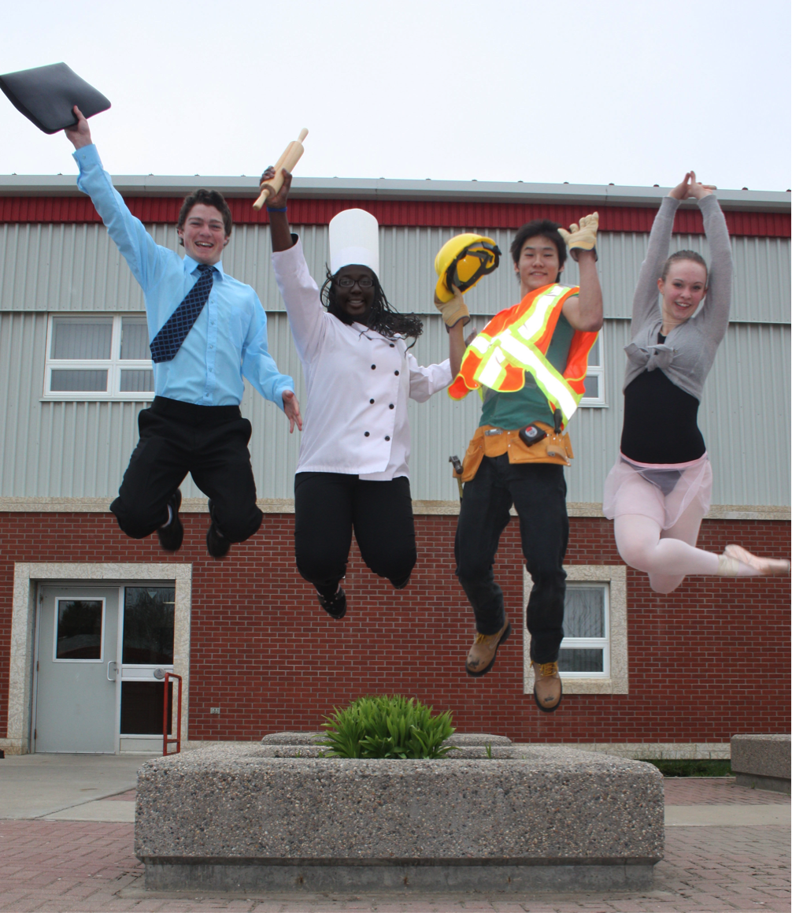


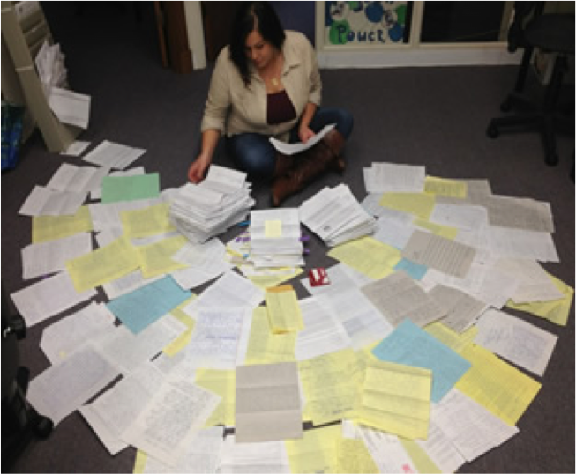

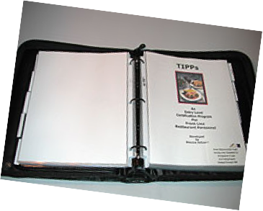

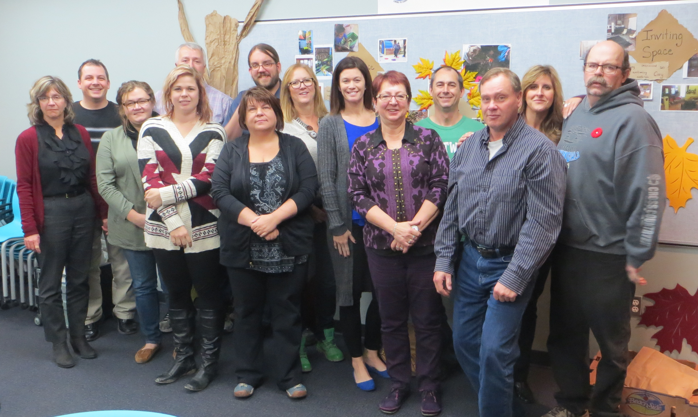


English 30
Implementation of Portfolio through Mock Interviews

A career portfolio is a visual representation of who you are. It highlights your skills, abilities, knowledge and talents through a collection of artifacts. Portfolios provide evidence of your potential by demonstrating what you accomplished in the past.
Career portfolios can be used not only as part of a job interview, college admissions interview, scholarship application or school leadership position, but as a self-reflection piece that shows the progress and growth you’ve made through your efforts and hard work. Through the creation of a personal portfolio, you begin to make the connection of learning at school to workplace readiness, which makes the school to work transition smooth and stress free.
A portfolio not only provides a well-rounded picture of yourself, but it allows you to understand and articulate the specific skills you have gained through the vast array of activities/experiences in which you have participated. Portfolios represent who you are and what you stand for.

  - Stand out!

Grade 12
Grade 11
English 20
Refinement of Portfolio for scholarships, employment, etc. purposes
Grade 10
Grade 9
Career Education
Portfolio Exploration and Creation
English 10
Revision of Portfolio

Scope and Sequence
If it is to be . . . . . it’s up to me.
- George Raveling
Pg. 1

What is a Portfolio?

Career Portfolios
Grade 9

Career Development
Living Sky School Division #202
Reflect
Collect
Select
A portfolio paints a picture of you as a whole student. It is not a ‘snapshot’ of a student on a particular day, but an evolving document depicting your progress and growth over time. It includes not only what you do in school, but also what you do while away from school. As new experiences are added to your portfolio, older dated materials are removed.
It is important to showcase a wide range of skills and abilities in your portfolio, as employers are looking for diversity and specific skills such as: fundamental skills (communication, information management, number usage and problem solving), personal management skills (positive attitudes and behaviours, responsibility, adaptability, continuous learning and working safely), and teamwork skills (working with others, participating in projects and tasks). It is vital that each of these traits be acknowledged in some capacity through your portfolio.
Values are also important. Showing that you are dependable, easy to get along with, hard working, independent, knowledgeable and current are important traits to highlight.
The first step of creating a portfolio is to collect photos, certificates, letters, etc. These are known as ‘artifacts’. After you have everything together, select only those pieces that tell a story about yourself and support your goal. This story, or purpose, is called a ‘reflection’. It explains the skills and abilities depicted in the artifact. Once you have selected and organized your evidence, it is time to format and compile your portfolio so it is easy for someone else to read and understand.
Portfolios can be either hardcopy or electronic. Hardcopy portfolios usually have artifacts that are placed into sheet protectors and arranged in a professional looking one-inch binder. Electronic portfolios vary but this format allows for the integration of technology and interaction.
Be sure to highlight your transferable skills mentioning both your hard (specific skill sets that can be defined and measured) and soft (interpersonal) skills.

How do all of my learnings and experiences fit into my life script of who I am and where I am going?

A portfolio is a living document.

It will be revisited and revised several times over your high school years.

A Lifelong Journey

For the next four years, you will be adding new experiences and knowledge to your portfolio.

- Thank you notes
- Certificates / Awards
- Photos / Newspaper Clippings
- Academic Achievement Awards
- Agenda/Calendar of Personal Time Management
- Career Exploration
- School Work Sample
- Student PD
  - Try-A-Trade
  - Career Fair
  - Student Conference
- Take Our Kids to Work Day report
- Safety Courses
- Job Application
- Team Involvement
- Club or Group Participation
- Work Experience
- Reference Letter
- Report Card
- Attendance Record
- Hobbies / Interests
- Volunteer Experience

Ideas:
Extra-curricular
Science Fair
Drama / Choir
Hunter Safety
Life Guarding
Babysitting
First Aid / CPR
Music / Band
Debate
Travel
Dance
Leadership
Community Involvement
Teams/Clubs
Writing Samples
Student Council
Cadets
Yearbook
Boating Safety Certificate
Ready for Work Certificate

In grade nine, you must include a …
- Cover Page
- Resume
- Personal Letter of Introduction Including Future Goals
- Interest Inventory / Personality Profile
You must also include a minimum of three additional artifacts accompanied by a reflection.

Portfolio

Check Sheet
Adopted from Manitoba Education’s “A Self-Managed Career Portfolio Guide (http://www.edu.gov.mb.ca/k12/docs/support/c_portfolio/index.html)
Proof of Skills | Reference letter
Explanation | I have done this for five years. | I have been asked to do another fundraiser.
Participate in Projects and Tasks | o | o
Work with Others |  | o
Work Safely | o
Learn Continuously | o
Be Adaptable | o | o
Be Responsible | o | o
Demonstrate Positive Attitudes and Behaviours | o | o
Think and Solve Problems | o | o
Use Numbers |  | o
Managing Information |  | o
Communicate |  | o
Activity | Mow lawn and shovel snow | Organise fundraiser

“Each portfolio is as unique as a fingerprint”

(Burke, Fogarty, Begrad)
For more information, please feel free to contact your school Career Counselor.
They can help get you started on the right path!
Extension Ideas:
Grade 10 | Grade 11 | Grade 12
Driver Education  Occupational Research  Job Application  Business Letter  CWE | Job Shadow  CCC Testing  Career Fair  Part-Time Job  Cover Letter  Reference Letter  CWE | Job Shadow  Career Fair/Try-A-Trade  Scholarship Application Scholarship Essay  Cover Letter  CWE  Diploma

Check out these sites . . .
Building a Personal and Career Portfolio (curriculum.org/storage/108/1278484153portfolios.pdf)
A Guide to Your Career Portfolio (www.potsdam.edu/offices/career/prepare/upload/Portfolio-Guide.pdf)
Employability Skills 2000+ (www.conferenceboard.ca/Libraries/educ_public/esp2000.sflb)
A Self-Managed Career Portfolio Guide (http://www.edu.gov.mb.ca/k12/docs/support/c_portfolio/index.html)
Eportfolios – video
(http://www.youtube.com/watch?v=nOYBvQbBFA&list=FLVFD8OSsV0WC4J8GAENedJQ&index=37&feature=plpp_video)
Ask Yourself . . .
- Does my portfolio show a wide-range of my accomplishments?
- Are my most important accomplishments clearly explained?
- Does my portfolio have a consistent format?
- Did I edit my portfolio for clarity, spelling, grammar and language?
- Is the sequence and organization logical?
- Does the format of my portfolio make it appealing and easy to read?
- Does my cover look professional with my name and contact information clearly displayed?
- Do my reflections show evidence of thoughtfulness, insight and growth?

Need some help?
Remember: More is not always better!

Portfolios should be visually aesthetic with clear, relevant, concise and interesting reflections.

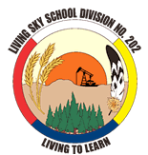

The ‘High 5’ Message of Career Development
- DO know your portfolio well and the placement of your artifacts
- DO refer to your portfolio during an interview to validate and enhance your statements
- DO highlight information that you want people to notice first
- DO include you contact information and ensure you use an appropriate email address
- DO convince people that you are what they are looking for . . . confidence is crucial
- DO be aware of body language when presenting your portfolio
- DO ensure the portfolio is easily accessible and well organized
- DO update your portfolio regularly
- DO keep the portfolio professional in appearance
- DON’T expect an interviewer to view your entire portfolio
- DON’T downplay your achievements . . . be proud of your accomplishments!

1. Change is constant
Many jobs of the 21st century haven’t been invented yet!
Be adaptable and flexible.
2. Follow your heart
Let your dreams shape your goals and go after what is really important to YOU!
3. Focus on the journey
As you evolve and life evolves around you, the place you thought you were heading many not look so enticing anymore. Or you may have decided you’d rather go off in another direction . . . or to somewhere else that hasn’t even shown up on your map yet!
4. Accessing your Allies
Family, friends, school and the community are there to help . . . draw from their knowledge and experience!
5. Learn continuously
You don’t stop learning after you finish school!

Dos and Don’ts

