NBCHS Vision Statement
BUILDING COMMUNITY, iNSPIRING SUCCESS
from possibility to actuality

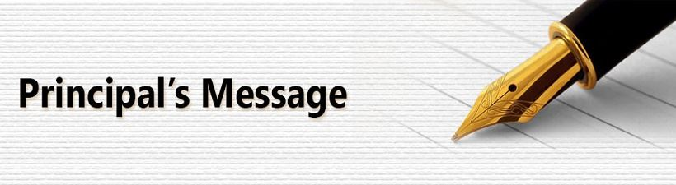Dear Students, Parents, and Families,
Welcome to another exciting school year at North Battleford Comprehensive High School! As the principal, I am thrilled to have the opportunity to work with such a diverse and vibrant community. Our school is committed to fostering an inclusive environment where every student feels valued and supported. We believe that diversity enriches our educational experience, and we celebrate the unique backgrounds, perspectives, and talents that each student brings to our school. This year, we have an array of extracurricular activities designed to engage and inspire our students, including a wide variety of sports teams, academic clubs, and creative arts programs. We encourage all students to explore their interests and get involved in these activities to develop new skills, build friendships, and create lasting memories.
Our dedicated staff is here to support your children in their academic and personal growth. We are committed to providing a safe and nurturing environment where students can thrive both inside and outside the classroom. We look forward to partnering with you to ensure that every student has the opportunity to reach their full potential. Together, we can make this school year a memorable and successful one. Thank you for entrusting us with your children's education, and we are excited to see what we can achieve together.
Warm regards, Jennifer Larocque
Principal, NBCHS
LIVING SKY SCHOOL DIVISION SHARED VALUES
- Genuine Relationships – Mutual Trust and Respect! We create trusting relationships starting with respect and strengthened by open communication, commitment and caring for others.
- Belonging – Everyone can play! We foster community through inclusion, acceptance, and equity.
- Integrity – Owning everything we do! We act honestly, consistently, and responsibly – living our values every day.
- Innovation – What if we could? We are dedicated to continuous growth and success – anticipating needs, challenging the status quo and being creative without limits.
- Wellbeing – Bringing our best every day! We foster a healthy, safe environment in which people can be their best.
BELL SCHEDULE:
Warning Bell 8:55 a.m.
Period 1 9:00 a.m. – 10:04 a.m.
Period 2 10:09 a.m. – 11:12 a.m.
Period 3 11:17 a.m. – 12:20 p.m.
Noon 12:20 p.m. – 1:05 p.m.
Period 4 1:10 p.m.- 2:14 p.m.
Period 5 2:19 p.m. – 3:22 p.m.

EARLY DISMISSAL DAY
Warning Bell 8:55 a.m.
Period 1 9:00 a.m. – 9:48 a.m.
Period 2 9:53 a.m. – 10:41 a.m.
Period 3 10:46 a.m. – 11:34 a.m.
Noon 11:34 p.m. – 12:15 p.m.
Period 4 12:20 p.m. – 1:08 pm.
Period 5 1:12 p.m. – 2:00 p.m.


STUDENT FEES
Student fees are assigned to students and must be paid upon registration. Compulsory and option fees are indicated as follows:

S.R.C. Fee $ 40.00
Caution Fee (Refundable) $ 25.00
Lock Fee (New Students) $ 12.00
Yearbook (Optional) $ 50.00

Other costs: Students shall be responsible for the costs of any supplies required in the subjects chosen.
Teachers will indicate fees early in each semester. Student fees can be paid by cash, cheque, debit/credit machine or through SchoolCash on the NBCHS website.

NOTE: Caution fees will only be refunded upon graduation or when a student moves to another school less any outstanding fees.

EXTRA-CURRICULAR FEES
Students may be charged fees dependent on the activity they join.

MENTAL HEALTH CAPACITY BUILDING INITIATIVE
MHCB is a program dedicated to promoting positive mental health and wellness in a way that is accessible for everybody. This is done through presentations in the classrooms, events in the school, and promotion of different topics/resources. Our goal is to ensure everybody feels equipped to handle life's challenges and knows where to go when struggling. We can't wait for another amazing year with NBCHS!

GATEWAY is a space for Indigenous students to come receive help on their education journey. It’s for students that need help with homework or planning out their futures, such as filling out applications and writing resumes. It also offers students a cultural space. We smudge every morning, make ribbon skirts, and create art. It is located directly to your right when you enter through the main entrance of NBCHS.

The Restorative Action Program (RAP):
RAP facilitators offer a trusted, judgment-free space with a focus on one-on-one relationship building and conflict resolution. Their objective is to empower youth to develop responses to resolve issues related to bullying, mental health and relationships.

RAP supports youth to:
navigate conflict
build relationships
reconnect with community

PERSONAL COUNSELLING
School counsellors will assist students and parents if difficulties arise with personal relationships and other matters which may affect behavior and school performance. Students and parents are encouraged to contact the Student Services Office to resolve difficulties. All interviews are held with the strictest confidence.

SCHOOL LIAISON
The school liaison works as a support for the students and families within the school. This includes helping with attendance, conducting home visits, referring to agencies within the community, the breakfast/lunch program and working to enhance the student’s lives with groups and other programming. Other services may include transportation to appointments, setting up team meetings, organizing awareness days and school speakers. Contact the Student Services Office to connect with the Liaison worker.
RCMP LIAISON OFFICER
The job of the RCMP Liaison Officer is to bridge the gap between our youth and law enforcement. The Constable provides educational information to our students in the form of presentations in areas such as drug use, community safety, as well as individual counselling and investigations as relates to this position. This is a project that has proven to be an important part of the school community.

ACADEMIC ADVISING

Students may obtain the most recent information on universities, technical institutes, training programs and other post-secondary institutions. Students can also arrange to take an interest inventory which helps them to understand their general work and career interest. The inventory will suggest various career and work options available to individuals.
RESOURCE CENTRE
The aim of the NBCHS library is to provide a resource-based program which will allow students to acquire the information skills necessary for life-long learning. Our library contains a wide variety of curriculum-related materials that can help teachers teach their subjects and help students complete assignments based on those subjects. Students are encouraged to use the library, not only for study and research, but for the many recreational reading materials available. Students are asked to respect the rights of others using the library; that is to keep the noise level reasonable and return materials on time.

All circulated resources can be checked out for 14 days. After 14 days it will be deemed overdue. After 95 days, resources will be deemed as lost and fines will be added to SchoolCash at the end of each Semester. Students must either return the item(s) or if they cannot be returned (lost, damaged, etc.) please come down and chat with us in the library.
All fines will be added to SchoolCash on the last day of Semester.
EXTRA-CURRICULAR
Students are encouraged to take advantage of the many Extra-Curricular activities provided at NBCHS. There are many different STUDENT ACTIVITIES available to meet the many needs of our students. Students are reminded that for ALL STUDENT ACTIVITIES, the STUDENT comes first. Students must meet their student obligations to participate in the activities. These duties include but are not limited to: REGULAR ATTENDANCE, COMPLETION of ASSIGNMENTS, and APPROPRIATE BEHAVIOUR.

STUDENT CONDUCT CODE
All student conduct should be based upon common sense, respect for all individuals and behavior which is civilized and responsible. We expect all students to follow established school rules. We cannot and will not tolerate defiance of any school authority or acts of violence or intimidation towards others.

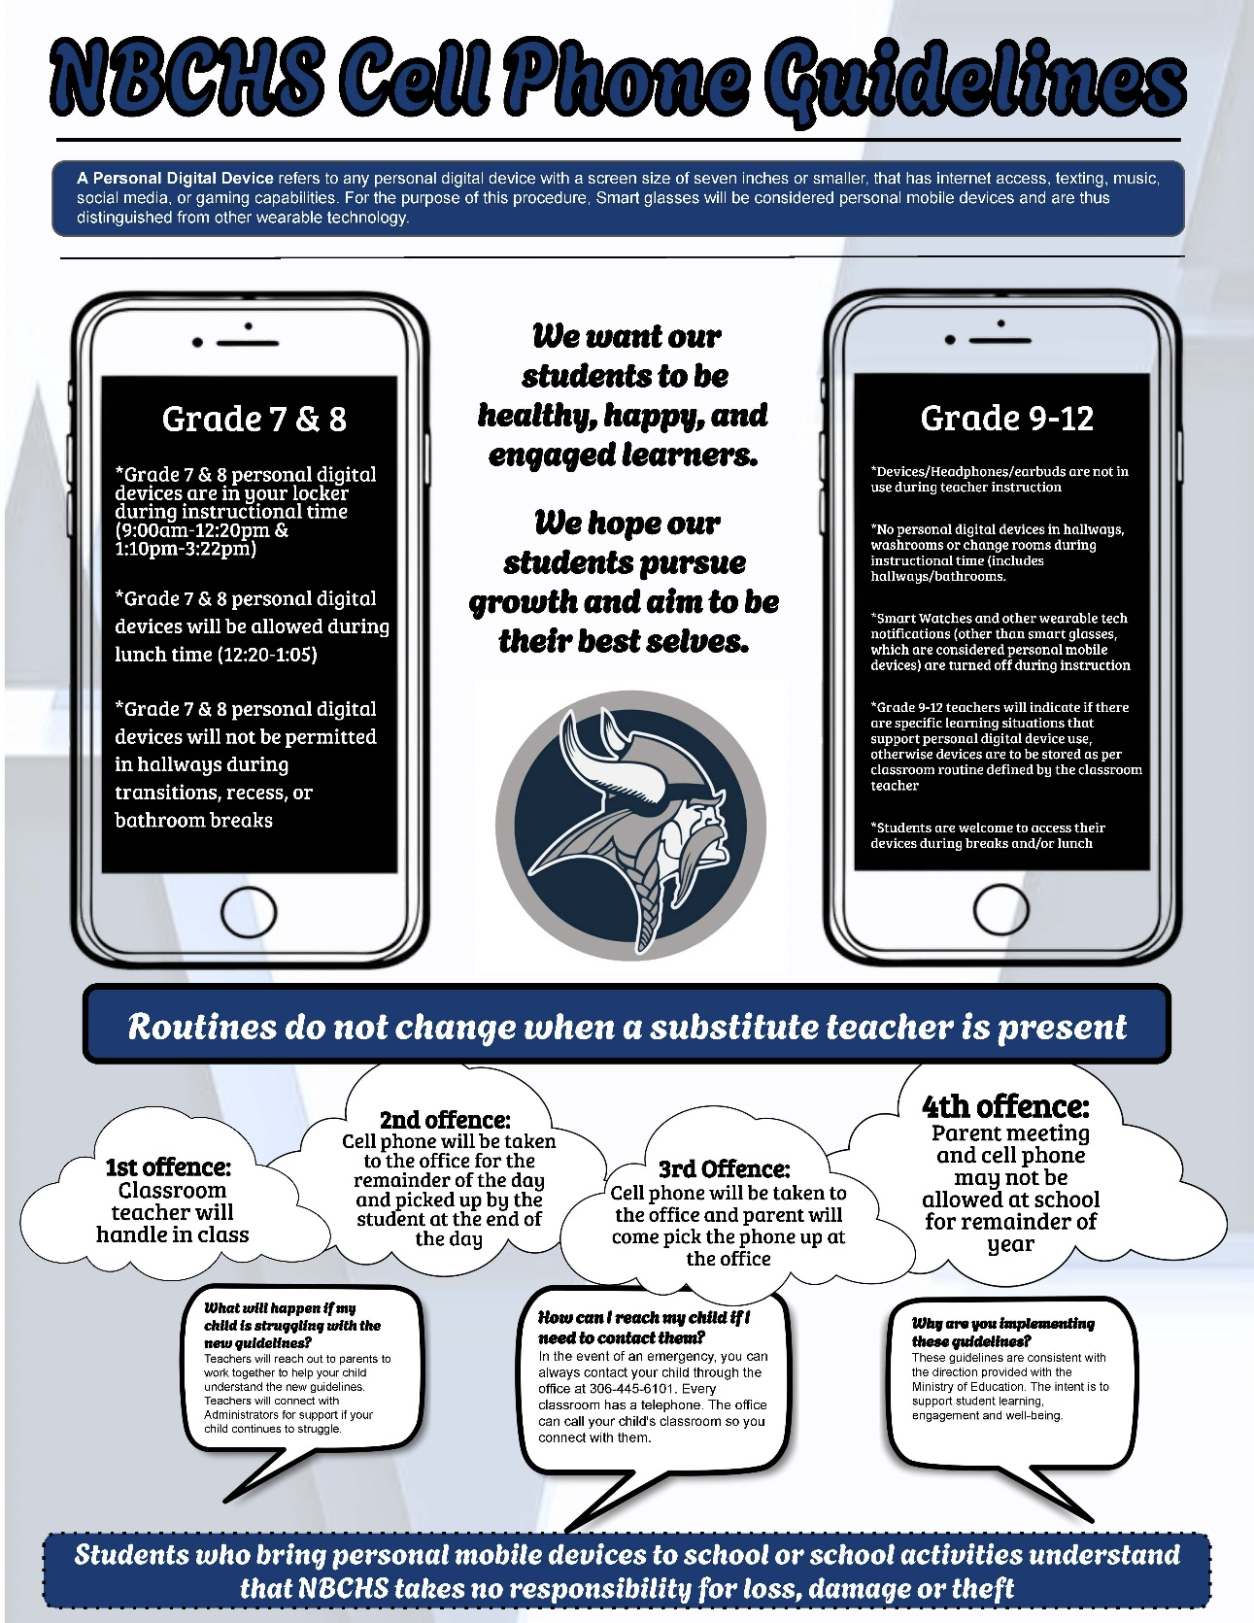

EDSBY
Parents and students are encouraged to access marks and attendance through EDSBY on the NBCHS webpage. Please contact the office if you require assistance setting up your account.

NBCHS STUDENT ACCEPTABLE USE POLICY FOR COMPUTERS AND THE INTERNET FOR EDUCATION PURPOSES
1. The NBCHS computer network has been established for a specific educational purpose. The term “educational purpose” includes classroom activities, career development and limited self-discovery activities.
2. The NBCHS network has not been established as a public access service or a public forum. NBCHS has the right to place reasonable restrictions on the material accessed or posted through the system. Students are expected to follow the rules set forth by the law and NBCHS (disciplinary code) on the use of the NBCHS network.
3. Students may not use the NBCHS network for commercial purposes. Students may not offer, provide, or purchase products or services through the NBCHS network.

INFORMATION ABOUT USER
ACCOUNTS FOR STUDENTS AND
PARENTS
At registration, a Living Sky account is
created for students which can be used
to sign into school computers, school
email, and connected services such as
Edsby.
Edsby and Student E-mail access is found at the NBCHS web page www.nbchs.lskysd.ca/

*Please also note that each student account is provided with $5 worth of printing at the beginning of the year. (Cost per page: 1¢ for black & white, 5¢ for colour). Any printing above this amount is the student’s responsibility.

Student Internet Access
1. All students will have access to the Internet through their classroom, library, or school computer lab.
2. Access to Internet resources will allow access to web-based e-mail accounts. Procedures and times regarding personal e-mail use will be determined by departments. The school may grant use of NBCHS e-mail accounts when required for a specific classroom related activity.
3. If approved by the school, students may create a personal Web page on the NBCHS System. All materials placed on a Web page must be pre-approved in a manner specified by the school. Students will not be allowed to store personal, non-educational Web pages in the server.
4. The school may at any point limit access to on-line resources.

Unacceptable Uses
1. Personal Safety
a) Students will not post personal contact information about themselves or other people. Personal contact information includes addresses, telephone numbers, school, or work address.
b) Unless they have their parent’s permission students will not meet with someone they have met online.
c) Students will promptly disclose to their teacher or other school employee, any message they receive that they believe is inappropriate or makes them feel uncomfortable.

2. Illegal Activities
a) Students will not use the NBCHS computer network to engage in any illegal act. The school will report illegal activities to the RCMP and co-operate in any investigation related to possible illegal activities.

b) Students will not attempt to gain unauthorized access to the NBCHS system or to any other computer network through the NBCHS system or go beyond their authorized access. This includes unauthorized attempts to log in through another person’s account or access another person’s files. These actions are illegal, even if only for the purpose of “browsing”. Students are responsible for all activities occurring on their account.
c) Students will not deliberately attempt to deny services to any users of the NBCHS network. These actions are illegal.
d) Students will respect copyright laws. If a work contains language that specifies appropriate use of that work, the expressed requirements should be followed. If a student is unsure whether a work can be used, permission should be requested from the copyright owner.

3. Inappropriate Communications
NBCHS reserves the right to restrict content of any public or private messages and any material posted on Web Pages. Students will not use inappropriate language in any communication via the NBCHS network.
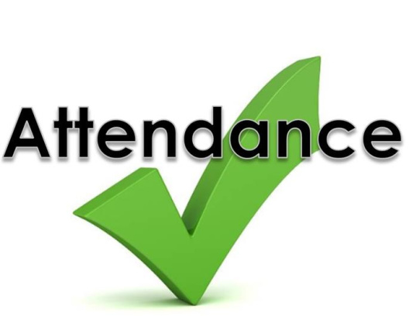
Students will not send communication that will damage their reputation.

4. Plagiarism
Students will not plagiarize works that they find on the Internet. Plagiarism is taking the ideas or writings of others and presenting them as if they were your own.

5. Access to Inappropriate Material
Students will not use the NBCHS network to access material that is profane or obscene (pornography), that advocates illegal acts, or that advocates violence or discrimination towards other people (hate literature). An exception may be made for these materials by teachers for the purpose of research. Parents may request alternate topics or assignments.
If a student mistakenly accesses inappropriate information, he or she should immediately inform a teacher or staff member. This will protect students against a claim of having intentionally violated the policy.

Consequences - Students found abusing or in violation of acceptable use policy may have their privileges limited or removed completely.

NBCHS ATTENDANCE POLICY
Regular school attendance is both a right and a responsibility. NBCHS administration and teachers will actively partner with students and parents to ensure students meet or exceed the attendance requirements of NBCHS and the Saskatchewan Education Act, 1995. NBCHS is committed to the full implementation of sections 156 to 162 of the Saskatchewan Education Act, which clearly defines student attendance as a responsibility that is shared among parents, students, teachers, principals, and the Board of Education.
NBCHS teachers recognize that consistent attendance, academic success, and school or grade completion have a direct correlation. The NBCHS Attendance Policy is not intended as a punitive measure. It aims to provide direction and to involve all stakeholders in achieving consistent attendance and therefore academic success for all students. Accurate course attendance records are imperative to the process. More information regarding number of unexcused hours allowed and strategy/action can be obtained at the Administration Office. Parents are encouraged to partake in regular communication regarding their student’s attendance.
The staff at NBCHS believes the following:

Regular attendance is essential to enable students to experience successful development of the provincial and local GOALS OF EDUCATION (basic skills, lifelong learning, understanding and relating to others, self-concept development, positive lifestyle, spiritual development, career and consumer decisions, membership in society, growing with change).
- Attendance is the PERSONAL RESPONSIBILITY of the student with the onus on the student to match his/her behavior to the attendance expectations of the school.
- The responsibilities of the school are to encourage regular attendance, monitor student attendance patterns and inform parents and students of attendance problems.

OBJECTIVES:

- To encourage and promote REGULAR ATTENDANCE as a prerequisite for success.
- To have students recognize and accept the RESPONSIBILITY and the CONSEQUENCES for their absence.
- To facilitate COMMUNICATION between the HOME and SCHOOL concerning attendance.
- To encourage students to make a COMMITMENT to stay in school.
- LATES - It is the student’s responsibility to be on time for class. Students who are late shall go directly to class. If a teacher considers it chronic lateness or the reason for lateness to be unacceptable, the student may be sent to ADMIN.

ACCIDENTS
Schools, like any other place, are not accident free. If an accident should occur, it must be reported to the office. The student may be taken to the hospital or an ambulance called. Parents will be notified.


VEHICLE COLLISIONS WILL BE THE RESPONSIBILITY OF THE DRIVERS AND OWNERS.

STUDENT PARKING
NBCHS cannot assume responsibility for damages to student vehicles. Students are not permitted to park within the staff parking lots of NBCHS and NWRC Staff.

STUDENT ATTIRE/DRESS CODE
Clothing must not display images, symbols, or language that are inappropriate for a school setting, including but not limited to the following: content that is vulgar, sexually suggestive, promotes violence, or demeans individuals or groups based on race, gender, culture, religion, sexual orientation, or ability.

Students may be asked to change into more appropriate apparel if they have:
- Visible undergarments.
- Low slung pants and tanks.
- Bandanas must not be worn on school property. They are considered gang symbols and are used by gangs for identification. The wearing of hoods inside the school is not permitted during the school day, except in cases where prior consent has been obtained from school administration or where an approved exemption applies.

GYMNASIUM
Appropriate gym clothing is required for all physical education classes. Use of the gymnasium by students at any time requires the permission of a physical education teacher.

LOCKERS ARE SCHOOL PROPERTY AND THE ADMINISTRATION RESERVES THE RIGHT TO INSPECT LOCKERS AT ANY TIME.
Only school locks may be used, and a record of the combination must be kept in the office. Locks will be sold to students at cost price. Students may trade in an old NBCHS lock for a new one in place of this fee. Replacement for damaged or lost locks may be purchased from the office. Students enrolled in Physical Education classes will be assigned a locker in the gym.

THE SCHOOL IS NOT RESPONSIBLE FOR ARTICLES MISSING FROM LOCKERS.
Students are advised to make certain that lockers are locked and valuables are not left out in the open. Students will be required to clean out their lockers on the designated day at the end of June. The school will not be responsible for any articles left in the lockers after that time. Students will be charged $5.00 if their lock is not removed by the deadline. Students will be assessed a $15.00 fee if lockers are not cleaned satisfactorily. Students will be charged $25.00 for damage to their locker.

TELEPHONE CALLS AND MESSAGES

Because of the difficulty and disruptions which occur in locating students, telephone calls and messages will be taken only in case of emergency.

TEXTBOOK POLICY
Textbooks, where required, will be provided on loan to each student at the beginning of each semester. Students are responsible for each textbook and are required to return all books at the end of the semester or when he/she discontinues school. A caution fee of $25.00 must be paid upon registration and will be refunded when all textbooks and other school property are returned in acceptable condition at the end of grade 12 or if moving to another school. Students who lose textbooks will be charged the cost of a new book.

LOST AND FOUND
The Board of Education cannot carry insurance for loss or theft of personal property. For example, electronic devices including iPods and cell phones. Students should clearly mark or identify all personal possessions so that they may be more easily traced.

STUDENTS VISITING OTHER SCHOOLS
Students should be aware that they are not allowed to visit other schools during the school day. The education law indicates that this is TRESPASSING. Students are not allowed to bring non-students on the property without the permission of the administration.

OPEN CAMPUS POLICY
North Battleford Comprehensive High School has an open campus policy meaning students have the choice to go off campus during lunchtime. NBCHS strongly encourages that students in grade 7-9 stay on campus during this time where they will be supervised. Students are expected to follow the rules and laws of the businesses they frequent and the community at large.

CAFETORIUM
Students who stay in the school during lunch hour are required to eat in the designated areas. We ask that all students help keep the cafetorium clean by getting rid of their own garbage, returning the trays, pushing in their chairs, etc.

FOOD, DRINKS AND LITTER ON SCHOOL PROPERTY
1. CAFETORIUM:
a) Each student sitting at a table is responsible to clean that table and area before leaving the table.
b) Garbage on and around the table must be put in a garbage container, cans/bottles placed in a recycling container and soiled dishes and trays placed on the racks.

2. HALLWAYS:
To enable us to keep our corridors a clean and healthy environment, we ask that students do not consume food and drinks in the hallways.

3. OUTSIDE SCHOOL PROPERTY:
a) Students who are observed littering outside will be reminded to clean up the mess.
b) Students are expected to dispose of garbage properly and return cans and bottles to the recycle containers inside the school.

TOBACCO/VAPING POLICY
Saskatchewan schools are tobacco-free zones. All tobacco and vapour products are banned, at all times, in schools and on any grounds owned by schools. Tobacco use, both smoked and smokeless tobacco, as well as vapour products are banned in schools and on school grounds. The Tobacco and Vapour Products Control Act supports healthy environments for students and families in the school community and applies to everyone, not just students and staff.
All products associated with the above, may be confiscated by staff.

USE AND ABUSE OF ALCOHOL OR DRUGS ON SCHOOL PROPERTY
Any student who is found in possession of or under the influence of alcohol or drugs on school premises or during authorized school activities will be dealt with by administration.

NORTH WEST COLLEGE
North West College shares part of the NBCHS building. NBCHS students are asked to stay on the High School side of the building and not use the NWC entrances/exits.

SASKATCHEWAN YOUTH APPRENTICESHIP
SYA is a provincial program available to all High School students enrolled in Technical/Vocational courses. Students can earn hours towards post-secondary training in the Trades and receive many other benefits from being a part of the program. More information is available from the Student Services Office.

APPRENTICESHIP
Allows High School students the opportunity to earn Apprenticeship and Career Work Experience credits while working on a job site. Students are still registered at NBCHS but complete these credits in the community. Students wishing to take part in this program should contact the Student Services Office for further information.


EVALUATION AND REPORT CARDS
The evaluation and assessment process at NBCHS is continuous, cumulative, and comprehensive. All students will receive a course outline at the outset of each course describing the evaluation/assessment that will be used during the course.

Students in High School courses (Grades 10-12) will receive percentage grades. Students must achieve 50% or higher to earn the credit and move on to the next course level. Mastery achievement levels of certain skill sets and tasks may be determined by the teacher and be higher than 50%.

Students in the Middle Years program (Grades 7-9) will be assessed on the 1- 4 rubric.

Progress Reports will be posted at the conclusion of the semester. Parents should check EDSBY regularly (see below). Although parent/student/teacher conferences are held after mid-term evaluation, parents are encouraged to follow the progress of their children closely and, if necessary, contact subject teachers if concerns arise.

GRADE XII SUPPLEMENTAL EXAMS
Students shall have the opportunity to write a Ministry of Education examination. Ministry prepared examinations shall be written at the next official sitting (Semester I students may write in January; Semester II students may write in August.) For more information contact the Student Services Office.

GRADUATION REQUIREMENT:
Students MUST fulfil the following criteria before your name will be placed on the PRELIMINARY GRAD LIST:

The student MUST have the potential to complete the 24 compulsory credits.

ADULT EDUCATION:
Under the SK Adult 12 Program, an adult may attain a Grade 12 standing by completion of seven credits. A minimum of five credits must be at the 30 level. All prerequisite requirements are waived for adults. Students must be 18 years of age and out of school for a minimum of 1 year or 19 years of age.
- One English Language Arts at level 30.
- One mathematics at level 20 or 30.
- One Canadian Studies at level 30.
- One Science course at level 20 or 30.
- Financial Literacy 30.
- Elective course at level 30.
- Elective course at level 30.

ADULT ALTERNATIVE EDUCATION:
The requirements for a SK Alternative Adult are:
Minimum of seven credits, five of which are at level 30; courses may be alternative education courses and regular education courses, including modified; locally developed courses may be used to meet elective requirements.
Course credit requirements are:
- One English Language Arts at level 30.
- One Mathematics at level 20 or 30.
- One Financial Literacy at level 10.
- Elective at the 20 or 30 level.
- Elective at the 20 or 30 level.
- Elective at the 20 or 30 level.
- Elective at the 20 or 30 level.

The student MUST have a CREDIT CHECK completed by a counsellor in the Student Services Office.

The student MUST NOT have outstanding fees owing to NBCHS.
Any student who has outstanding school fees will not be allowed to participate in NBCHS graduation exercises unless COMPLETE payment has been received by the last school day in MARCH of the current school year.

Students who are failing REQUIRED credits at MID-TERM of semester two WILL BE removed from the GRAD LIST and placed on academic probation. Students may be reinstated to the GRAD LIST during the last week in May if THE STUDENT REQUESTS a REVIEW and has a PASSING mark in all REQUIRED subjects as of May 31st.

STUDENTS REQUESTING REVIEWS during the last week of May will apply to Ms. Larocque at the Administration Office after May 31st.
If students DO NOT request a review by the end of the last week of May, they will be permanently removed from the GRAD LIST.


PRINCIPAL’S HONOUR ROLL
The North Battleford Comprehensive High School Honour Roll is designed to recognize student achievements in subjects taken during a school year. The Honour Roll will consist of two categories for regular academic subjects. Students with averages 80 – 89.4% will receive certificates for being on the school’s honor roll. Students with averages 89.5% – 100% will receive certificates specified Honour roll with distinction. Honour roll is based on final marks of the first semester and midterm marks from the second semester. Students are advised that the criteria for selection to the Principal’s Honour Roll is calculated using the following regular subjects:

1. Grade 10 – English 10, Math 10, Financial Literacy 10, Science 10, Canadian Studies 10, plus two 10 level elective (7 credits)
2. Grade 11 – English 20, Math 20, a Science 20, a Social Science 20, plus two 20 level elective (6 credits)
3. Grade 12 – English 30 (2 credits), a Canadian Studies 30, a Math 30, a Science 30, plus two other 30 level elective in regular academic courses (7 credits)

The top academic achiever in grade levels 10, 11 and 12 will receive the academic proficiency award/trophy, which will be recognized at the NBCHS Awards nights.

NBCHS VALEDICTORIAN
Valedictorian candidates are selected based on their academic performance across specific subjects. The criteria used these subjects by the end of May:
- Top English 30 Marks: Achievement in English Language Arts courses at the 30-level.
- Top Social Science 30 Mark: Achievement in Social Studies or related subject at the 30-level.
- Top Mathematics 30 Mark: Achievement in Mathematics course at the 30-level.
- Top Science 30 Mark: Achievement in Science course at the 30-level.
- Two 30-Level Electives: Achievement in any two elective subjects at the 30-level.

Candidates eligibility for valedictorian is determined by their cumulative performance across these academic areas, often emphasizing excellence in both core subjects and electives.

SCHOLARSHIPS AND AWARDS
A considerable number of scholarships and awards are available to students graduating from NBCHS. Students are encouraged to apply for scholarships by contacting the Guidance Counsellors. Please read the announcements (and listen to announcements) for a current update of available scholarships.

NBCHS GRADUATION AWARDS
The monetary awards given out at the graduation exercises are provided by businesses in the community and from interest earned on family donated (memorial) scholarship funds. NBCHS has a commitment to provide as many students as possible with monetary awards. The awards committee will determine the recipients based on the guidelines established and does its best to give each eligible winner the maximum amount of scholarship or bursary money available.

SPECIAL RECOGNITION AWARDS:
These are not Honour Roll Awards.
1. The school will recognize one student in each of grade 10, 11 and 12 with the highest academic achievement award who is taking modified 11, 21, 31 courses and other electives. Maximum five or six classes – depending upon the grade level.
2. The school will recognize the student in each of grade 10, 11 and 12 with the highest academic achievement in the courses offered at the 18, 28, 38 level based on their program.
3. The school will recognize students from each of grade 9, 10, 11 and 12 Special Education Functionally Integrated programs who have shown excellent improvement in their individualized programs.

AWARDS POINT SYSTEM PHILOSOPHY

1. Participation and academic excellence are the major basis of points.
2. Minor, Major and Grand Major awards are based on 6 years of participation.
AWARDS:
- Minor -110-169 points
- Major – 170-229 points
- Grand Major – 230 plus points

ACADEMIC POINTS
All averages for NBCHS Honor Roll, scholarships and bursaries will be calculated using Department of Education guidelines for
Grade 10, 11, 12 credits.
- 90%-100% - 5 points per subject, 7 points per subject for I.B. classes
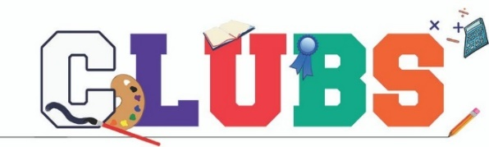
- 80-89% - 4 points per subject, 5 points per subject for I.B. classes

ACTIVITY CLUB POINTS
Each student is encouraged to join one or more of the following SRC approved clubs. The following will be taken in consideration: eligibility (attending regularly), where there is an executive, the executive member may receive up to five (5) points at the discretion of the Staff Advisor. Students will earn points as a Junior for Grade 7-9 and Senior Grades 10-12. Jr and Sr. points are not cumulative.
2 POINT ACTIVITIES:
• Viking Store (per semester)
• Cooking/Baking Club
• Volunteer
• Golf
• Other clubs that meet once or twice

5 POINT ACTIVITIES:
• Beading
• Ribbon Skirt
• Minecraft
• Coding
• Pottery/Art
• Skills Canada
• Junior Badminton
• Junior Curling
• Gr. 7 Basketball
• Gr. 7 Volleyball
• Cross Country
• Yearbook
• Grad Committees
• Gay Straight Alliance Club
• 3D Printing/Robotics
• Magazine Club
• Film Club
• TV Club
• DJ Club
• Greenhouse Club
• Cosmo Club

10 POINT ACTIVITIES:
• SRC
• Jazz Band
• Concert Band
• Choir
• Drama (per production)
• Junior Volleyball
• Junior Football
• Junior B Basketball
• Senior Curling
• Soccer
• Senior Badminton
• Track & Field

15 POINT ACTIVITIES:
• Junior A Basketball
• Senior Volleyball
• Senior Basketball
• Senior Football

• Captains of Senior teams may earn an additional 5 points
• Teams/clubs representing NBCHS at Provincial competitions may earn an additional 5 points

ACADEMIC REQUIREMENTS
Students enrolled at NBCHS are required to enroll in classes according to the following criteria:

Grade 7-9
Students will register in the required program as set out by the Ministry of Education and NBCHS. Students ARE allowed spares. Exceptions to this policy are at the discretion of the administration.

Grade 10 Year
- 1 English Language Arts
- 1 Mathematics
Math 10 Foundations
Math 10 Workplace
- 1 Financial Literacy
- 1 Science
Science 10
- 1 Social Studies
Social Studies 10
History 10
Indigenous Studies 10
- 1 Wellness 10
- 4 Electives

Grade 11 Year
- 1 English Language Arts
- 1 Mathematics
Math 20 Foundation
Math 20 Pre-Calculus
Math 20 Workplace
- 1 Science
Health Science 20
Environmental Science 20
Physical Science 20
- Social Science
(not required, can be an elective)
- 7 Electives (minimum of 6)

Grade 12 Year
- 1 English Language Arts
- 1 Canadian Studies
Social Studies 30
History 30
Indigenous Studies 30
- 2 - 30 Level Elective
(can include Math & Science)

ELECTIVES:
Physical Education: Football 20, Volleyball 20/30 and Physical Education 20/30

Fine Arts: Guitar 10/20/30, Band 10/20/30, Art 10/20/30 and Drama 10/20/30

Practical Applied Arts: Accounting 10/20/30, Agriculture Pro 10/20, Apprenticeship A & B 20/30, Career & Work Exp 10/20/30, Commercial Cooking 10/20/30, Construction 10/20/30, Creative Writing 20, Communications Media 20, Digital Photography 10/20,
Drafting 10/20/30, Emergency SRT 10, Financial Literacy 20/30, Forensic Science 20, Hairstyling & Esthetics 10/20/30, History 20,
Info Processing 10/20/30, Journalism 20, Life Transitions 20/30, Machining 10/20/30, Mechanical 10/20/30, Media Studies 20,
Mental Health & Wellbeing 20, Personal Fitness 20, Psychology 20, Social Studies 20, Sports Psychology 20, Welding 10/20/30 and
Wildlife & Habitat 10/20

NOTE: IB courses meet all requirements in same subject area. Please see academic advisor for specific graduation requirements.

Important Dates:
August 26-31 Non-Student Days
August 31 Meet the Teacher Night

September 1 Non-Student Days
September 2 First Day of classes
September 2-3 Sr. Girls Volleyball Tryouts @ 5:30 p.m.
September 7 Labour Day
September 11 Student/Staff Photo Day
September 12 Jr. Girls A Team Volleyball Home Tournament
September 14 Student/Staff Photo Day
September 15 Grade 12 Extended Essay Outline due
September 23 Early Dismissal Day @ 2PM
September 30 PD Day – No School
September 30 Grade 11 HL English Final Paper due

October 12 Thanksgiving Day
October 15 Grade 12 Extended Essay 1st Draft due
October 16-17 Sr. Girls Volleyball Home Tournament
October 21 Early Dismissal Day @ 2PM
October 23-24 Sr. Boys Volleyball Home Tournament
October 26 PD Day – No School
October 27 Student/Staff Photo Retake Day
October 30-31 Band Camp

November 1 Grade 11 Chemistry SL Internal Assessment Topic Chosen
November 2 IB Exam Meeting
November 6 IB Exam Registration Deadline
November 9-13 Book Fair
November 10 Grade 12 Biology HL Topic/Experimental Design
November 11 Remembrance Day – No School
November 15 Grade 12 Extended Essay 2nd Draft due
November 19 Student Led Conferences 4-9 PM
November 25 Early Dismissal Day @ 2PM
November 27 -28 Sr. Boys Basketball @ PA Carlton
November 27-28 Sr. Girls Basketball @ PA St. Mary’s
November 30 Grade 12 Theory of Knowledge Presentations

December 1 Grade 12 Math SL Internal Assessment Exploration Topic Chosen
December 4-5 Sr. Girls Basketball @ Regina Balfour
December 3-5 Sr. Boys Basketball Fekula Classic (Regina Balfour)
December 9 Winter Music Concert
December 11-12 Sr. Girls Basketball @ Saskatoon Centennial
December 10-12 Sr. Boys Basketball C4 Classic Saskatoon
December 11 Jr. Basketball Tournament
December 12 Jr. Basketball Tournament
December 18 Early Dismissal Day @ 2:30 PM
December 20 History SL/HL Internal Assessment Draft due
December 21-31 Christmas Break
December 25 Christmas Day
December 26 Boxing Day

January 1 New Year’s Day
January 4 Classes resume
January 8-9 Sr. Girls Basketball @ Prince Albert Carlton
January 8-9 Sr. Boys Basketball @ Swift Current
January 10 Grade 12 Biology HL Topic/Experimental Design 1st Draft due
January 15 Grade 12 Extended Essay Final Draft due
January 15 Grade 12 Math SL Internal Assessment Exploration Draft due
January 15-16 Sr. Girls Basketball @ Moose Jaw Peacock
January 15-16 Sr. Boys Basketball @ Meadow Lake
January 20 Early Dismissal Day @ 2PM
January 25 Summative Assessment Day
January 26 P1 Exam @ 9:00 AM; P2 Exam @ 12:50 PM
January 27 P3 Exam @ 9:00 AM; P4 Exam @ 12:50 PM
January 28 P5 Exam @ 9:00 AM; Summative Assessment PM
January 29 Non-Student Day (STF Day)
January 29-30 Sr. Girls Basketball @ Lloydminster Comprehensive
January 29-30 Sr. Boys Basketball (Lloyd Border Classic)

February 4-6 Sr. Boys Basketball (SMIT PA)
February 5-6 Sr. Girls Basketball Home Tournament
February 9 Student Photo Day
February 14 Valentines Day
February 15 Grade 12 Theory of Knowledge Essay due
February 15 Family Day – No School
February 15 Grade 12 History SL/HL Internal Assessment Final due
February 16-19 Winter Break
February 22-26 Grad Photos
February 26-27 Sr. Boys Basketball @ Moose Jaw Peacock
February 26-27 Sr. Girls Basketball @ Estevan Comprehensive
February 24 Early Dismissal Day @ 2PM
February 28 Grade 12 Biology HL Topic/Experimental Design Final due

March 5-6 Sr. Boys Basketball Home Tournament
March 12 PD Day – No School
Mach 12-13 Sr. Boys Basketball Regional Tournament (Location TBD)
March 15 Grade 12 Math SL Internal Assessment Exploration Final due
March 15 Grade 11 Chemistry SL Internal Assessment Topic Draft due
March 15 Grade 12 French SL Internal Assessment
March 15-19 Battlefords Kiwanis Music Festival
March 17 Early Dismissal Day @ 2PM
March 17 St. Patrick’s Day
March 18-20 Sr. Boys Basketball Hoopla Provincials (Regina)
March 25 Grad Photos – Retake Day
March 26 Good Friday – No School
March 30 Grade 12 Oral Examination completed
March 29-Apr 2 Easter Break

April 1 Grade 11 Chemistry SL Internal Assessment Topic Final due
April 10 Grade 12 French SL Oral Examinations
April 12 PD Day – No School
April 13-16 Feeder School Visits
April 19-23 Book Fair
April 21 Early Dismissal Day @ 2PM
April 28 Open House Night
April 29 Student Led Conferences 4-9 PM

May 3 IB Exams Begin
May 9 Mother’s Day
May 10 PD Day – No School
May 19 Early Dismissal Day @ 2PM
May 24 Victoria Day – No School
May 26 IB Awards Banquet
May 31 Sr. Awards Night
May 31 Grade 11 English HL Paper Draft

June 1 Jr. Awards Night
June 9 Hall of Fame
June 10 Year End Band Concert
June 20 Father’s Day
June 22 Summative Assessment Day
June 23 P1 Exam @ 9:00 AM; P2 Exam @ 12:50 PM
June 24 P3 Exam @ 9:00 AM; P4 Exam @ 12:50 PM
June 25 P5 Exam @ 12;50 PM; Summative Assessment PM
TBD Grad Rehearsal and lunch
June 28 GRADUATION CEREMONY @ 10:00 AM
June 28 Non-Student Day
June 29 Non-Student Day

